**Current (4 ques.):**

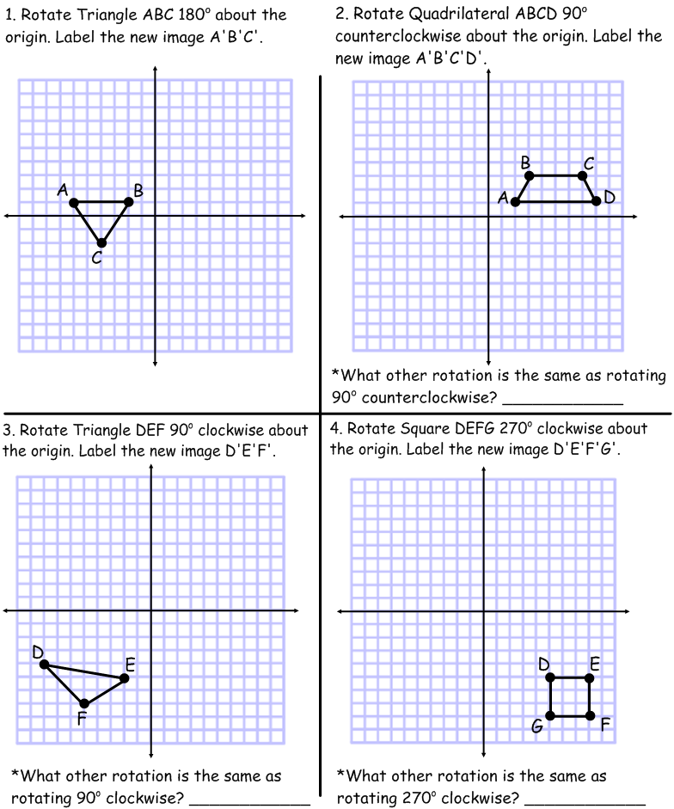

**Review (3 ques.):**

**Paper & Pencil**

**(K, 1, 2, 3, 4, 5, 6, 7)**

**5.  6. **

**(September - Now)**

**7. Simplify:**



**Fluency (2 ques.):**

**(8)**

**8. -4(4x + 8) = -5x - 10 9. Solve the system:**

**2x -5y = 34**

**8x + y = 10**